**PROJECT**

**ZABBIX MONITORING**

**INSTALLATION, CONFIGURATION AND MANAGEMENT**

**INSTALLATION**

**STRUCTURE ZABBIX**

**Configuring a host:**

**Host**: In Zabbix, a "host" refers to any **physical** or **virtual device**, **application**, **service**, or any other logically-related collection of monitored parameters.

* **Creating hosts is one of the first monitoring tasks in Zabbix**
* **To configure a host in Zabbix frontend, do the following:**
* **Go to: Data collection > Hosts or Monitoring > Hosts**
* **Click on Create host to the right (or on the host name to edit an existing host)**
* **Enter parameters of the host in the form**

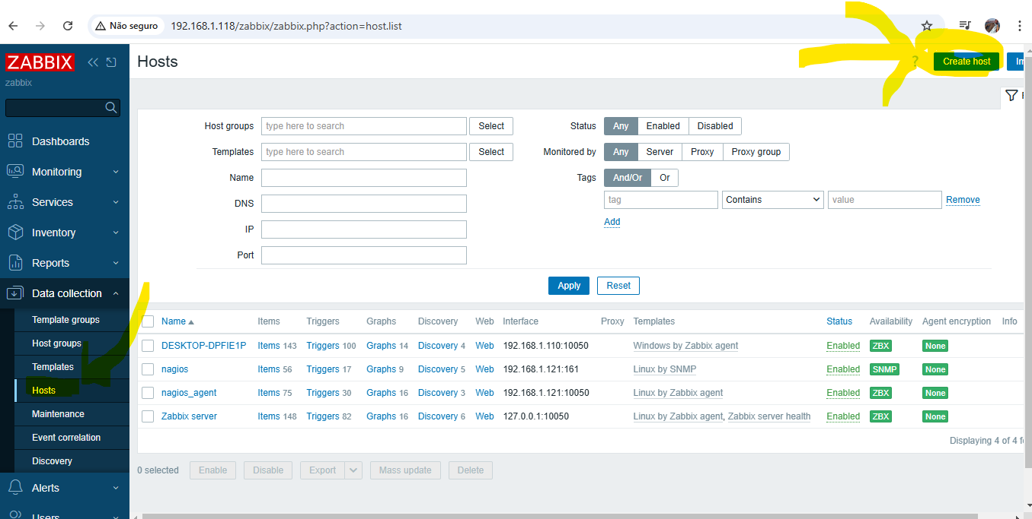

You can also use the **Clone** **button** in the configuration form of an existing host to create a new host. This host will have all of the properties of the existing host, including linked **templates**, entities (**items**, **triggers**, etc.) from those templates, as well as the entities directly attached to the existing host.

Note that when a host is cloned, it will retain all template entities as they are originally on the template. Any changes to those entities made on the existing host level (such as changed item interval, modified regular expression or added prototypes to the low-level discovery rule) will not be cloned to the new host; instead they will be as on the template.

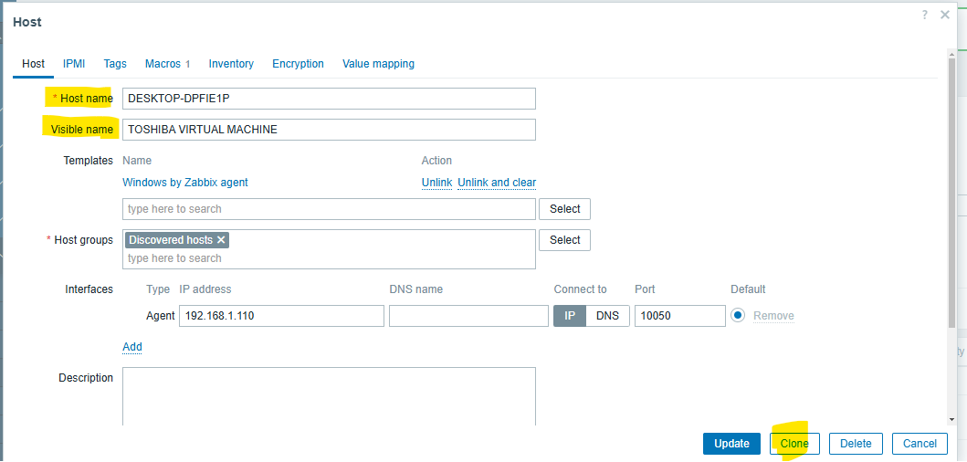

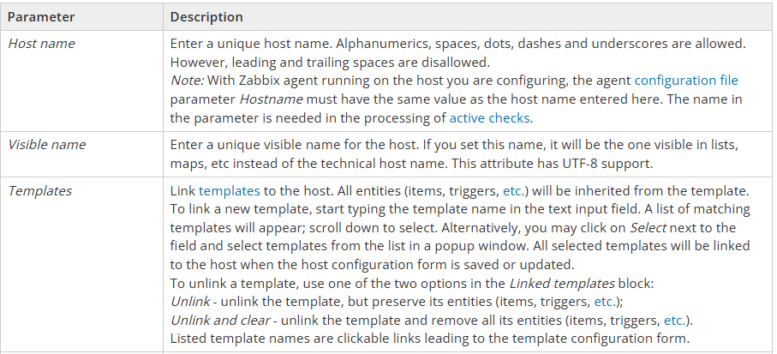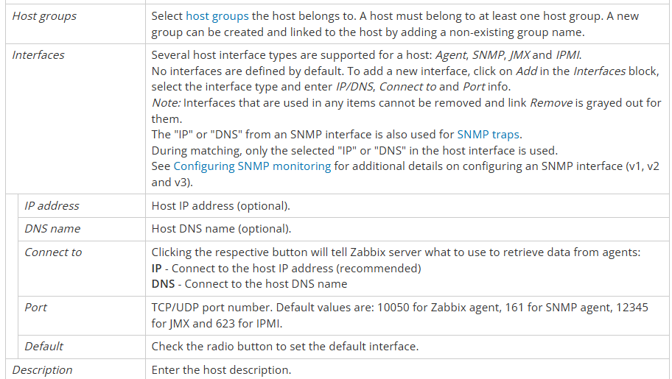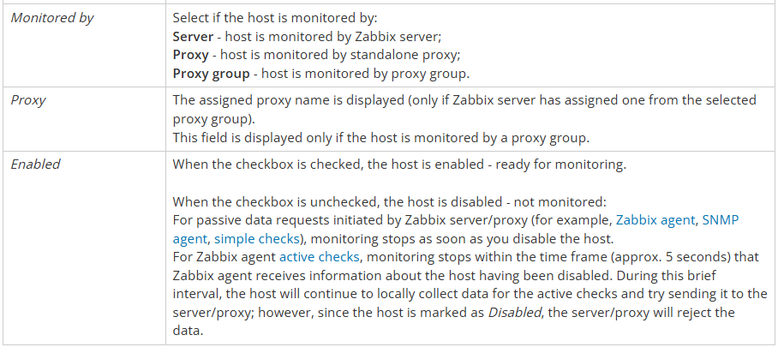

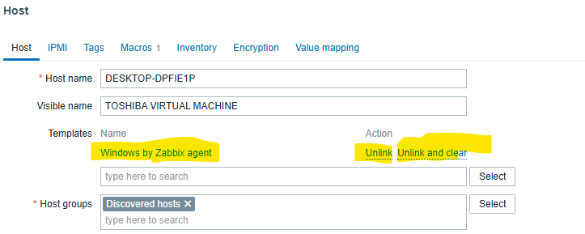

* ***Host groups****: Select*[*host groups*](https://www.zabbix.com/documentation/current/en/manual/config/hosts/host_groups)*the host belongs to. A host must belong to at least one host group. A new group can be created and linked to the host by adding a non-existing group name.*

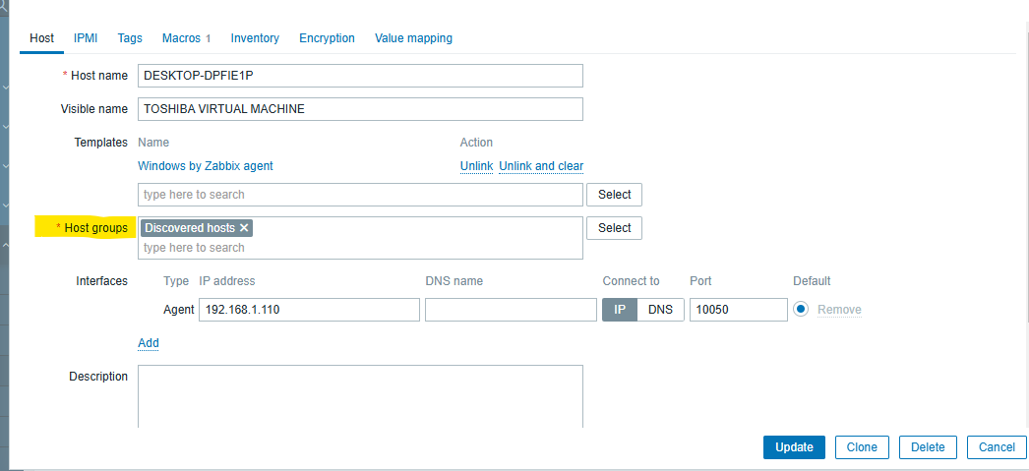

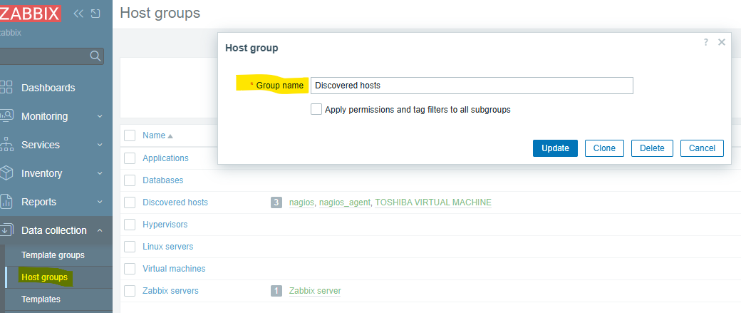

* ***Interfaces****: Several host interface types are supported for a host: Agent, SNMP, JMX and IPMI.  
  No interfaces are defined by default. To add a new interface, click on Add in the Interfaces block, select the interface type and enter IP/DNS, Connect to and Port info.****Note****: Interfaces that are used in any items cannot be removed and link Remove is grayed out for them.  
  The "IP" or "DNS" from an SNMP interface is also used for*[*SNMP traps*](https://www.zabbix.com/documentation/current/en/manual/config/items/itemtypes/snmptrap)*.  
  During matching, only the selected "IP" or "DNS" in the host interface is used.  
  See*[*Configuring SNMP monitoring*](https://www.zabbix.com/documentation/current/en/manual/config/items/itemtypes/snmp#configuring-snmp-monitoring)*for additional details on configuring an SNMP interface (v1, v2 and v3).*
* ***IP address****: Host IP address (optional).*
* ***DNS name****: Host DNS name (optional).*
* ***Connect to****: Clicking the respective button will tell Zabbix server what to use to retrieve data from agents:****IP****- Connect to the host IP address (recommended)****DNS****- Connect to the host DNS name*
* ***Port****: TCP/UDP port number. Default values are:* ***10050 for Zabbix agent****,* ***161 for SNMP agent****,* ***12345 for JMX*** *and* ***623 for IPMI****.*
* ***Monitored by****: Select if the host is monitored by:****Server****- host is monitored by Zabbix server;****Proxy****- host is monitored by standalone proxy;****Proxy group****- host is monitored by proxy group.*
* ***Proxy****: The assigned proxy name is displayed (only if Zabbix server has assigned one from the selected proxy group).  
  This field is displayed only if the host is monitored by a proxy group*
* ***Enabled****: When the checkbox is checked, the host is enabled - ready for monitoring.  
  When the checkbox is unchecked, the host is disabled - not monitored:  
  For passive data requests initiated by Zabbix server/proxy (for example,*[*Zabbix agent*](https://www.zabbix.com/documentation/current/en/manual/appendix/items/activepassive#passive-checks)*,*[*SNMP agent*](https://www.zabbix.com/documentation/current/en/manual/config/items/itemtypes/snmp)*,*[*simple checks*](https://www.zabbix.com/documentation/current/en/manual/config/items/itemtypes/simple_checks)*), monitoring stops as soon as you disable the host.  
  For Zabbix agent*[*active checks*](https://www.zabbix.com/documentation/current/en/manual/appendix/items/activepassive#active-checks)*, monitoring stops within the time frame (approx. 5 seconds) that Zabbix agent receives information about the host having been disabled. During this brief interval, the host will continue to locally collect data for the active checks and try sending it to the server/proxy; however, since the host is marked as Disabled, the server/proxy will reject the data.*

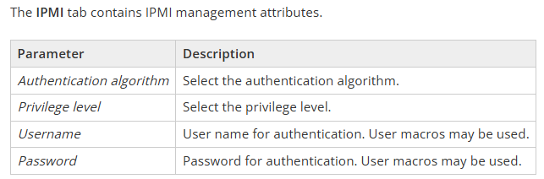

*The****Tags****tab allows you to define host-level*[*tags*](https://www.zabbix.com/documentation/current/en/manual/config/tagging)*. All problems of this host will be tagged with the values entered here.*

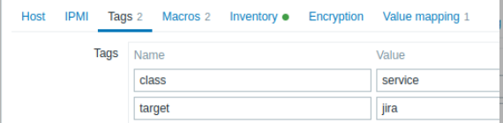

* *User macros, {INVENTORY.*} macros, {HOST.HOST}, {HOST.NAME}, {HOST.CONN}, {HOST.DNS}, {HOST.IP}, {HOST.PORT} and {HOST.ID} macros are supported in tags.*
* *The****Macros****tab allows you to define host-level*[*user macros*](https://www.zabbix.com/documentation/current/en/manual/config/macros/user_macros)*as a name-value pairs. Note that macro values can be kept as plain text, secret text or Vault secret. Adding a description is also supported.*

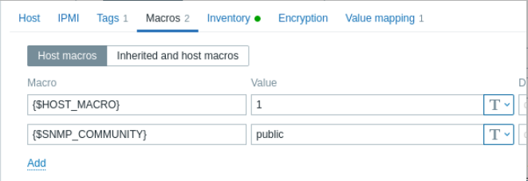

* *You may also view here template-level and global user macros if you select the*Inherited and host macros*option. That is where all defined user macros for the host are displayed with the value they resolve to as well as their origin.*

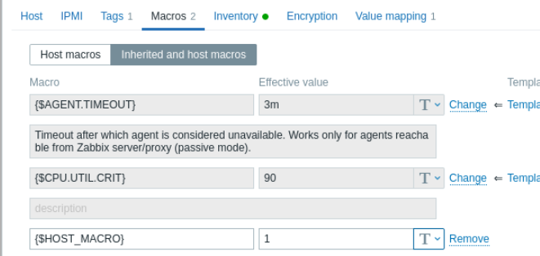

* *For convenience, links to respective templates and global macro configuration are provided. It is also possible to edit a template/global macro on the host level, effectively creating a copy of the macro on the host.*
* *The****Inventory****tab allows you to manually enter*[*inventory*](https://www.zabbix.com/documentation/current/en/manual/config/hosts/inventory)*information for the host. You can also select to enable*Automatic*inventory population, or disable inventory population for this host.*

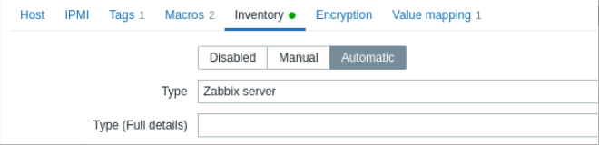

* *If inventory is enabled (manual or automatic), a green dot is displayed with the tab name.*

***Encryption***

* *The****Encryption****tab allows you to require*[*encrypted*](https://www.zabbix.com/documentation/current/en/manual/encryption)*connections with the host.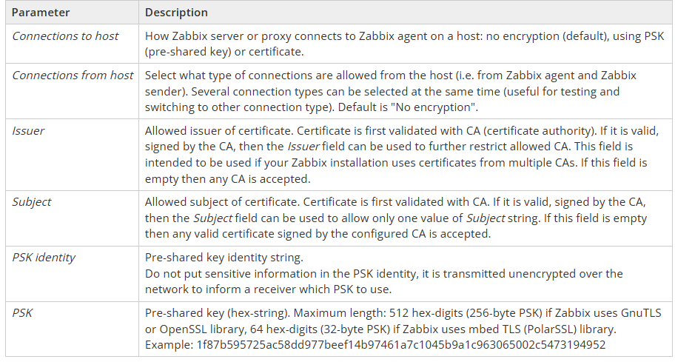*

**ZABBIX AGENT (UNIX)**

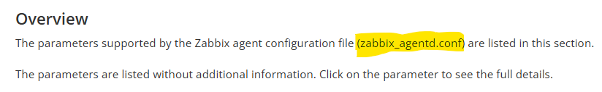 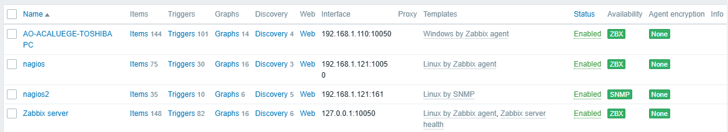



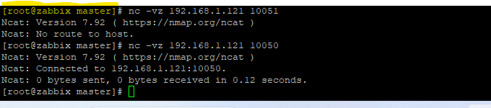

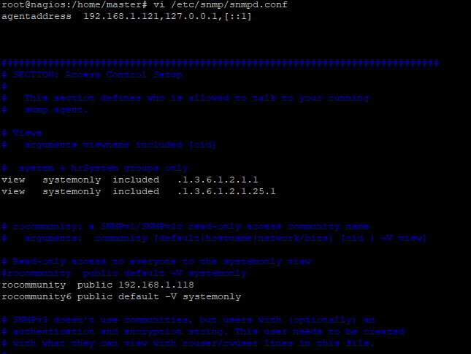

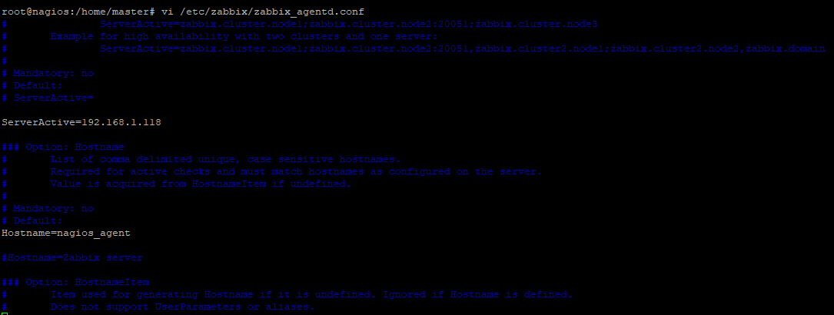

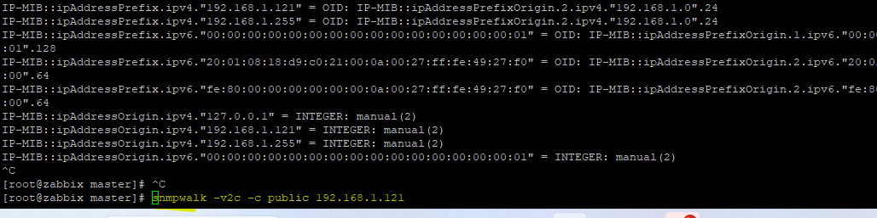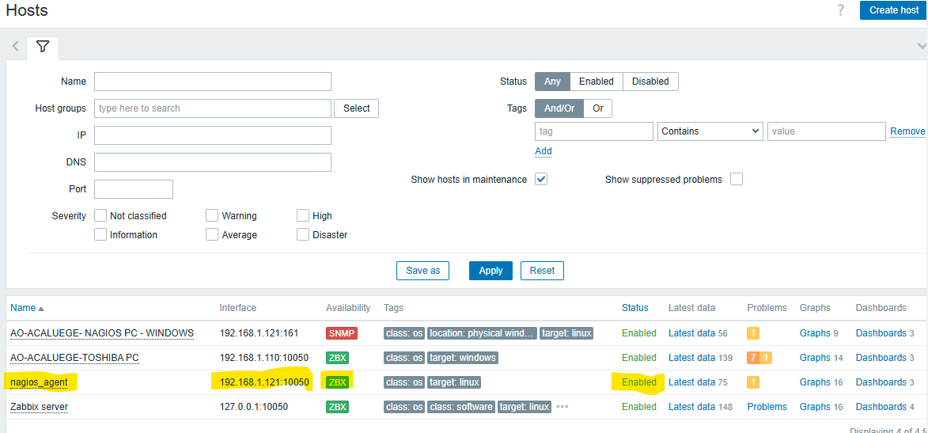

**NOTIFICATION MAIL**

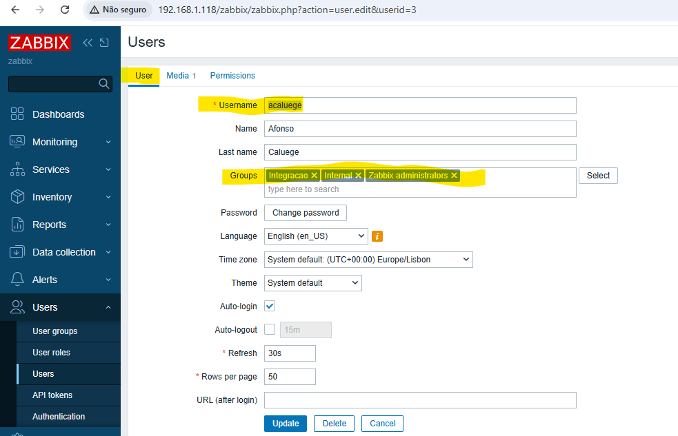 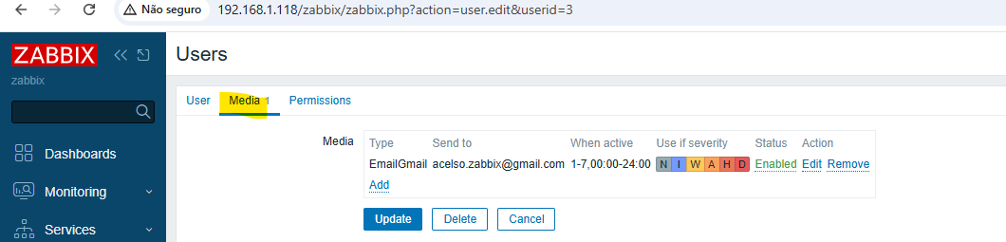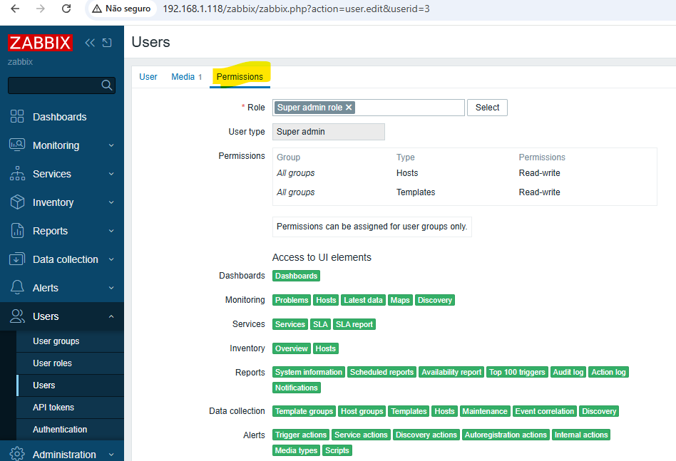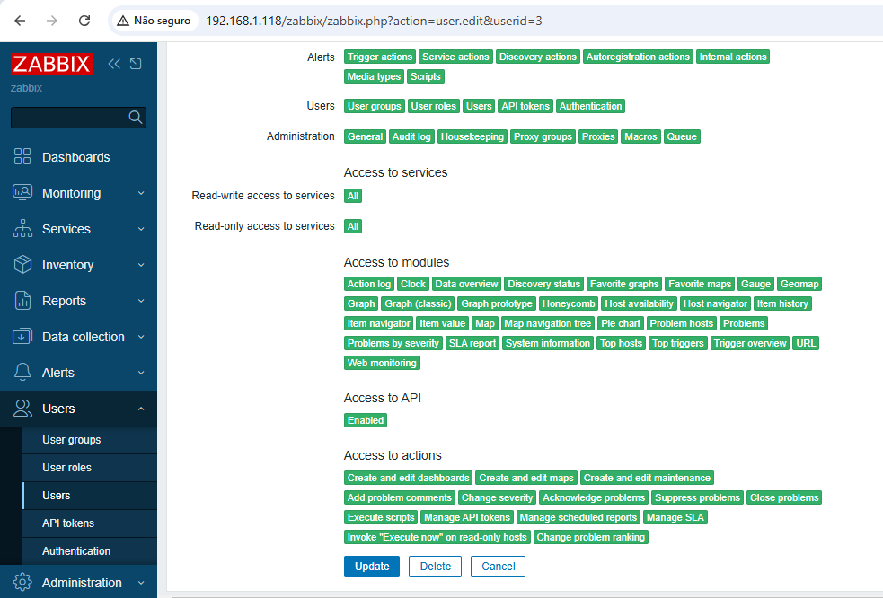

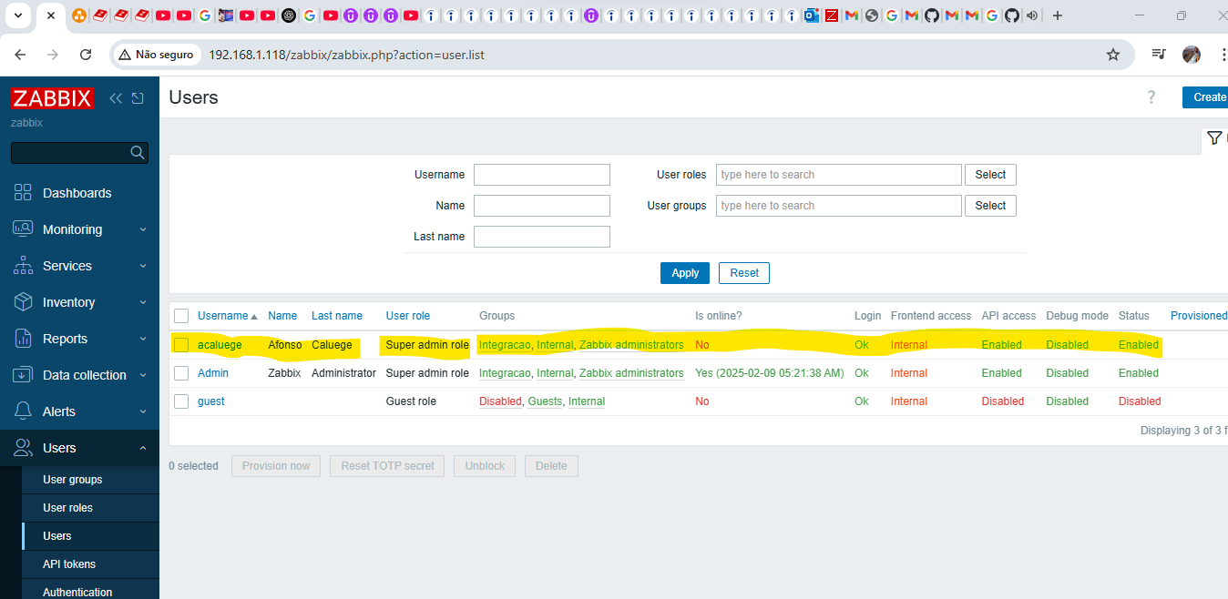

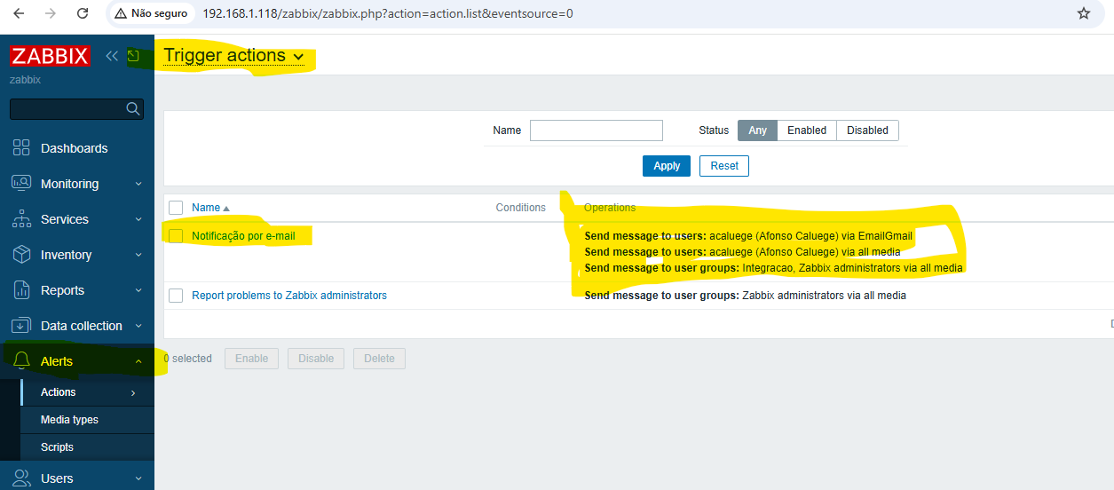 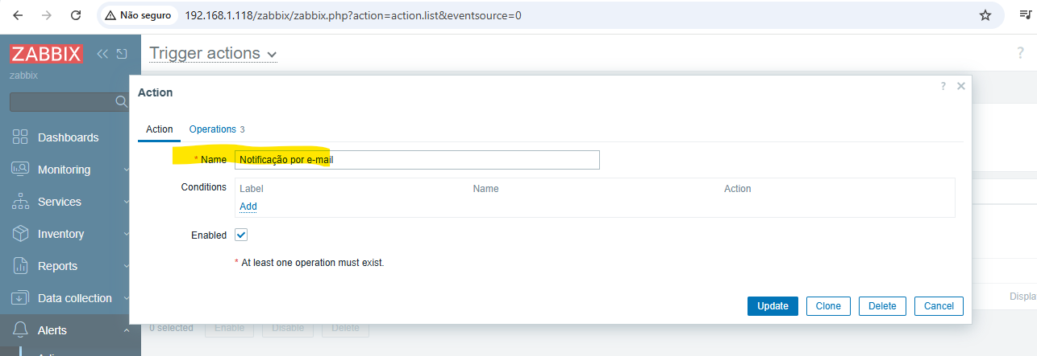 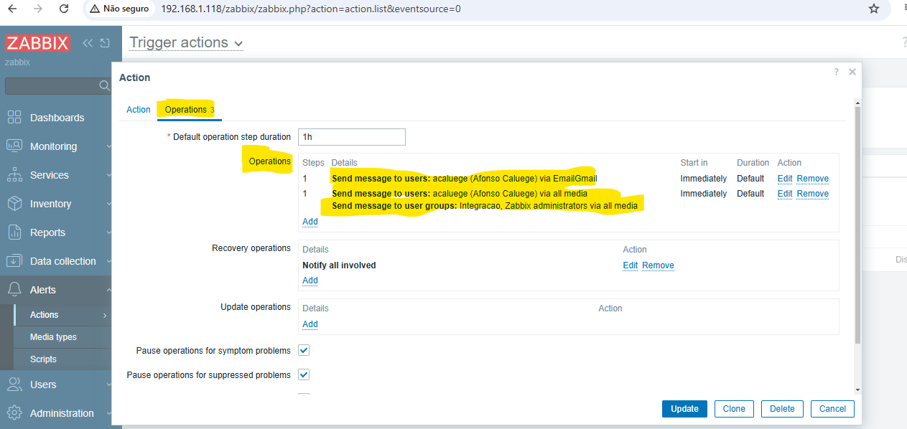

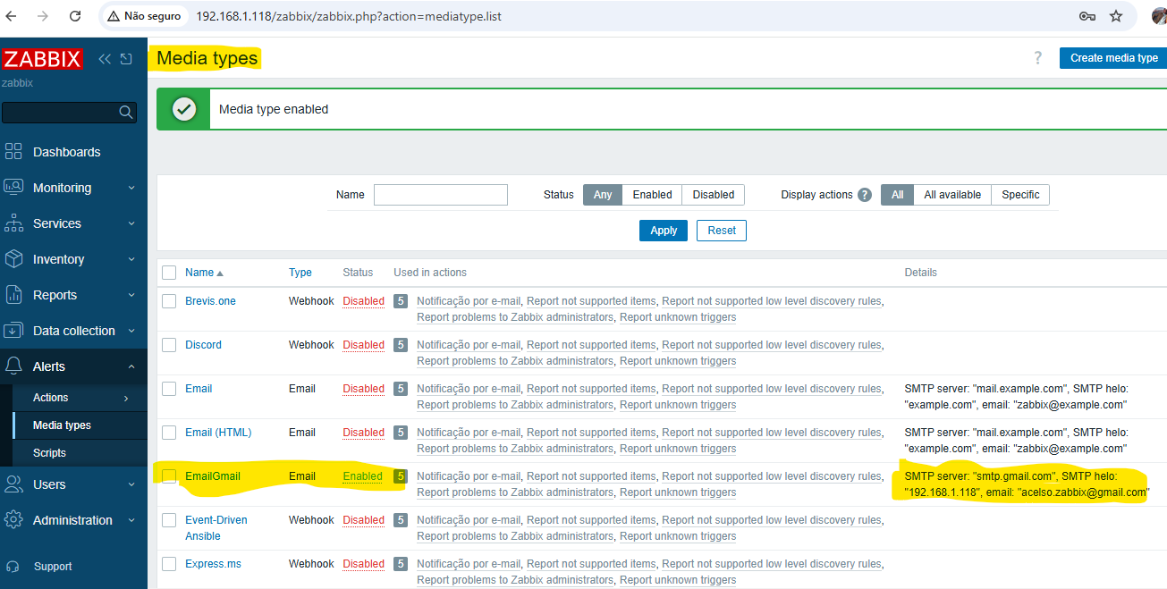

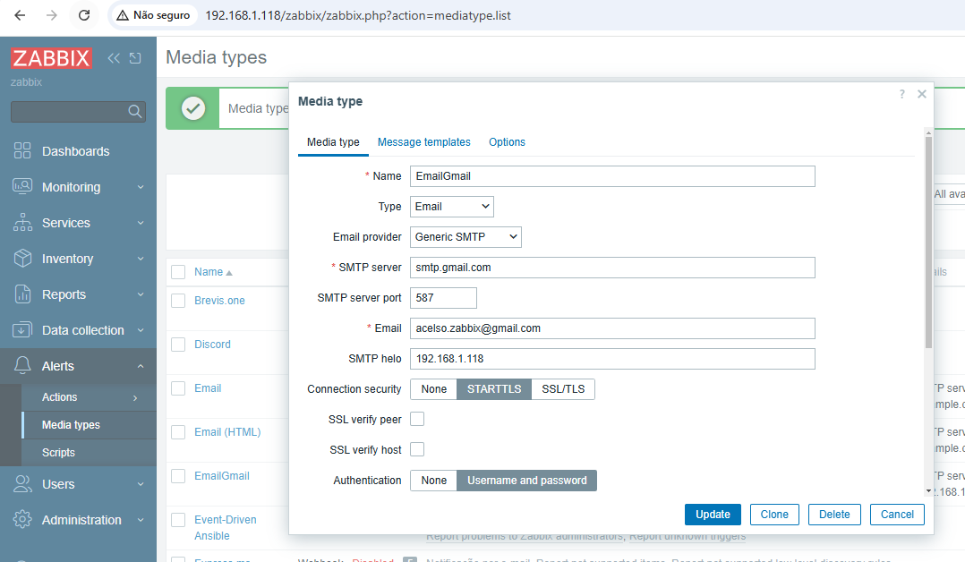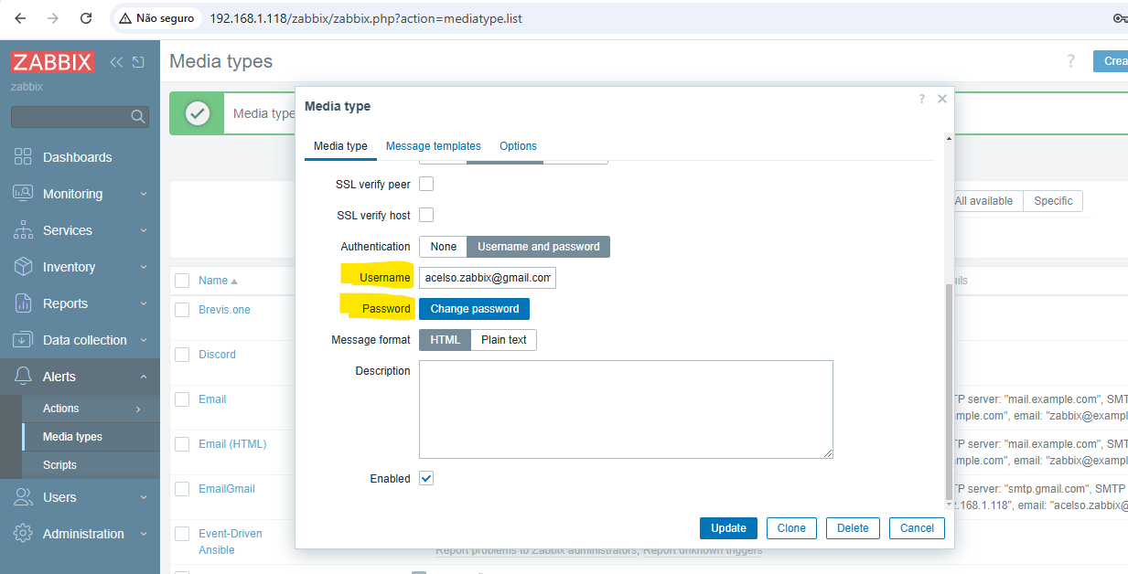

**NOTA: GMAIL**

[**https://myaccount.google.com/security?rapt=AEjHL4N1ixXgl9ZvPx_yFZ8pao2lD_t2bD6VSg-Oph1qW4e5Xe0eXV1_A1k6C1X6M09MD2Ida_5_S5m4Z6d6zn8xpN0slE-NzCEUXW-5R4yf6jiIjwhBziY**](https://myaccount.google.com/security?rapt=AEjHL4N1ixXgl9ZvPx_yFZ8pao2lD_t2bD6VSg-Oph1qW4e5Xe0eXV1_A1k6C1X6M09MD2Ida_5_S5m4Z6d6zn8xpN0slE-NzCEUXW-5R4yf6jiIjwhBziY)

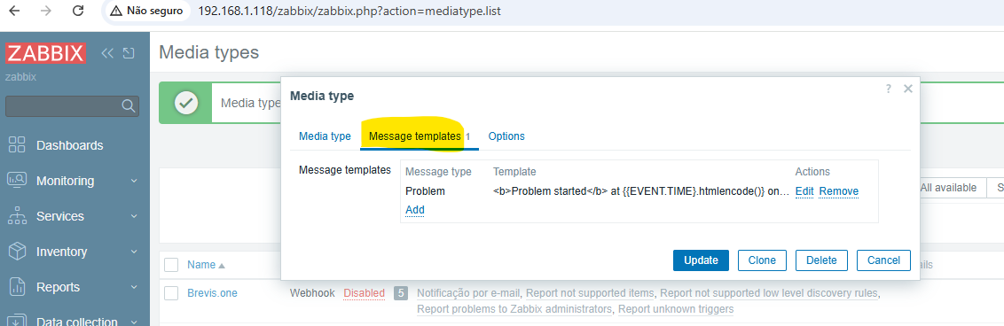

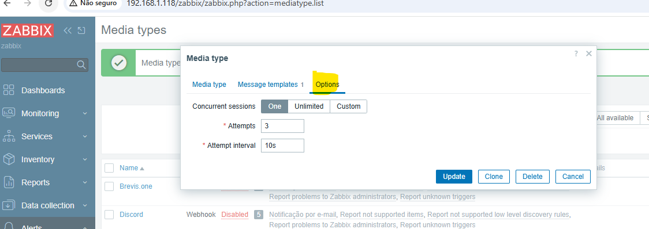

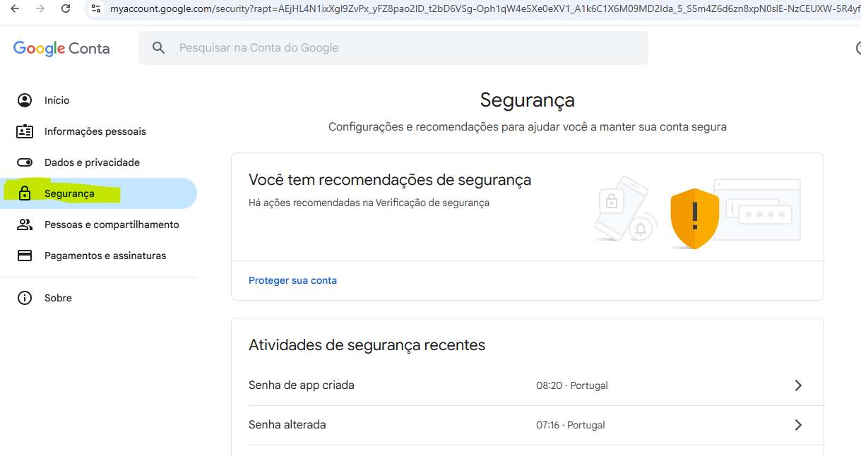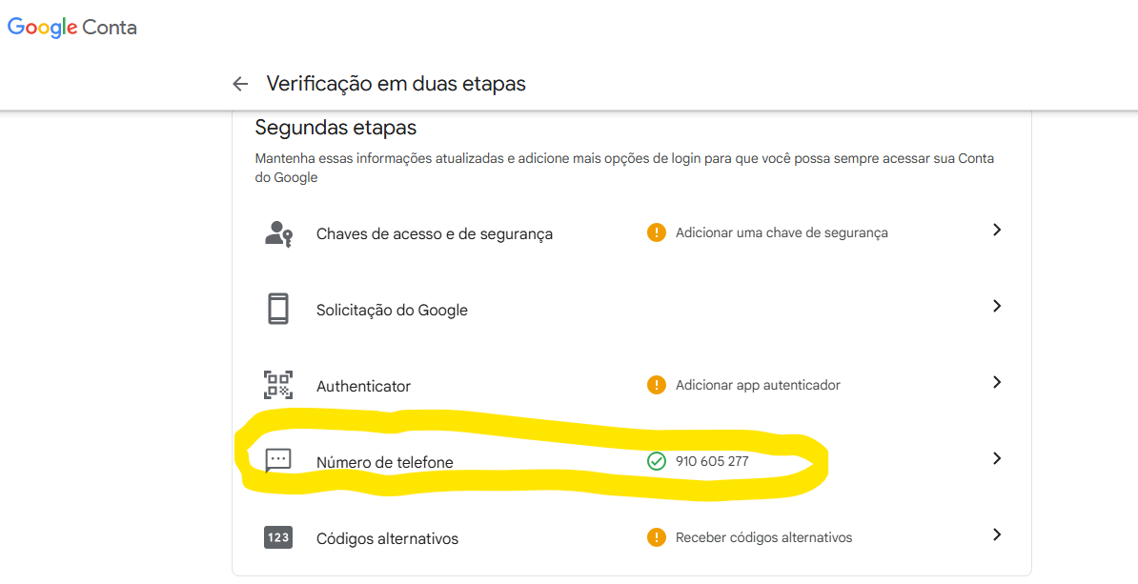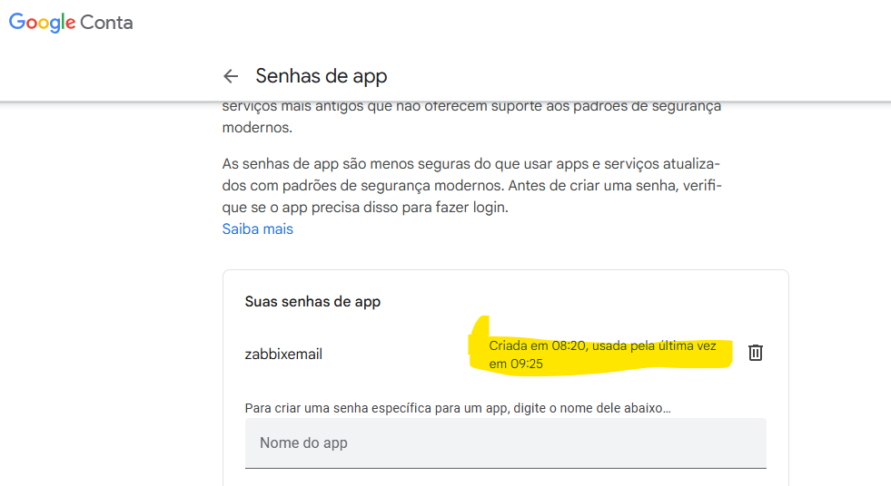

**OBS: COPIAR A SENHA GERADA E COLOR NO EMAIL ZABBIX: aclkfc almy zkswac**

[**acelso.zabbix@gmail.com**](mailto:acelso.zabbix@gmail.com)

**Pw: aclkfc almy zkswac**

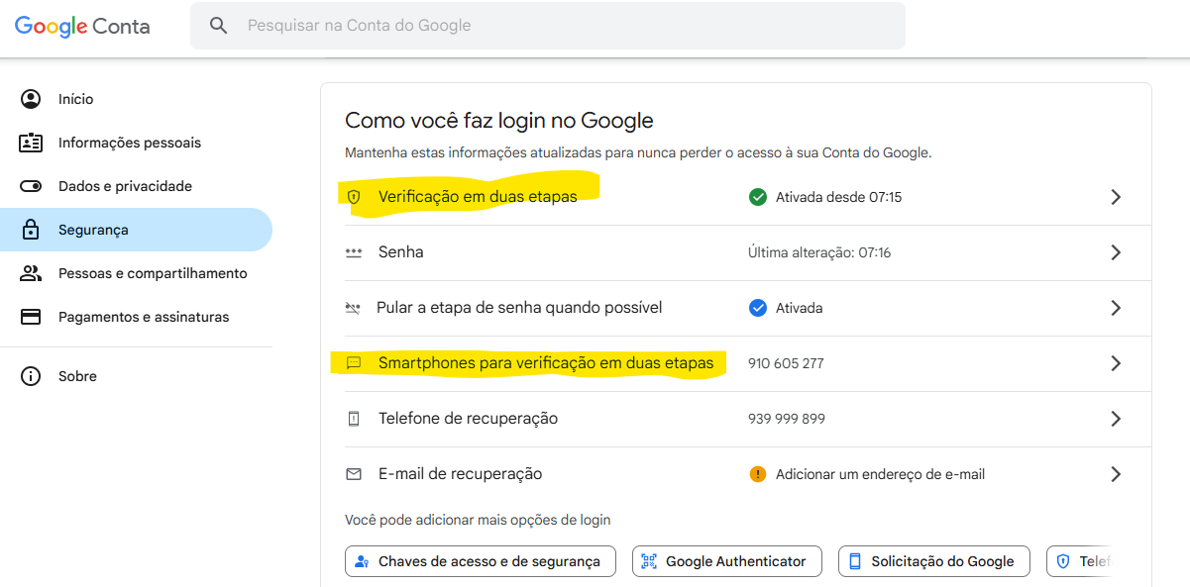

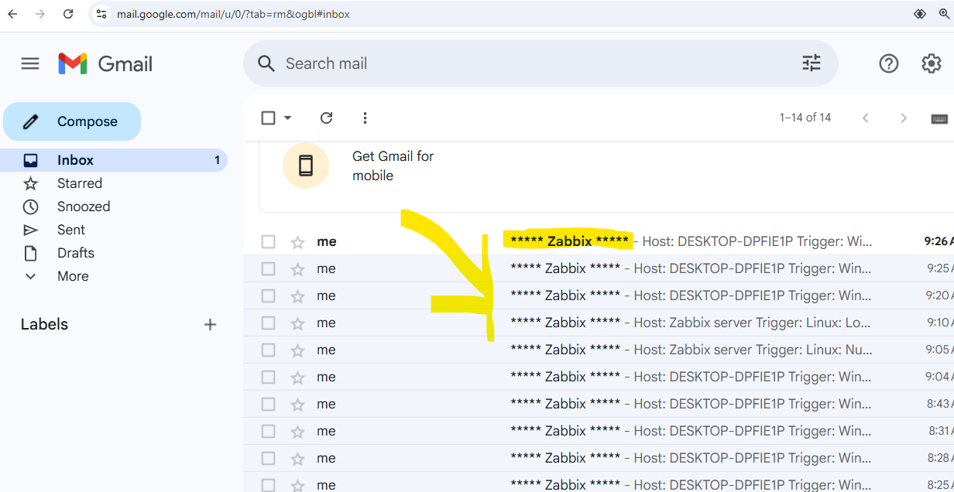

**PARAMETRIZAR CORPO MENSAGEM**

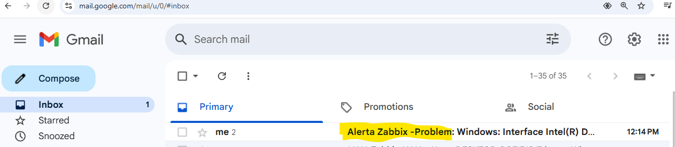

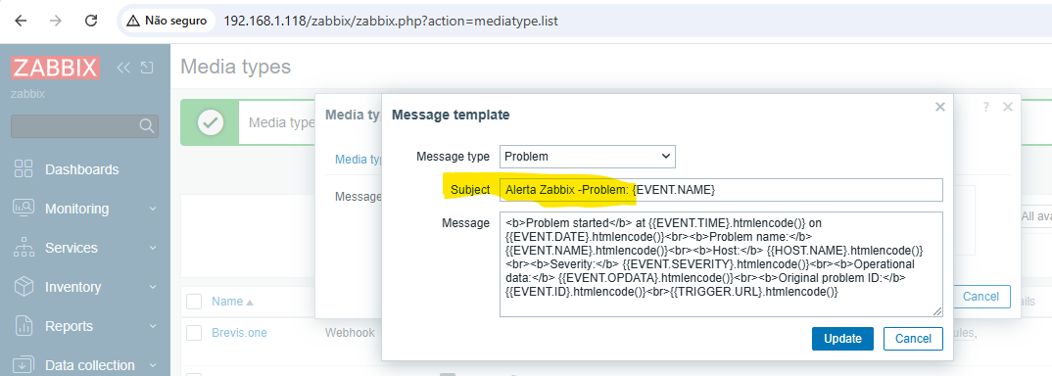

**B**